Learning Journal Unit 7

Godfrey Ouma
University of the People
CS 1101: Programming Fundamentals
Janice Block
August 3, 2023

Learning Journal Unit 7
- Construct a Python dictionary that returns a list of values for each key. The key can be whatever type you want.
- Creating a Python dictionary
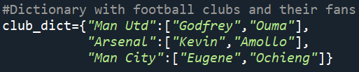
The code above shows a Python dictionary that returns a list of values for each key (Downey, 2015). The dictionary will be used to track different football clubs and the people who are their ardent fan. Therefore, the keys will represent different football clubs, while the values will be people supporting those clubs.
- Modifying the invert_dict function
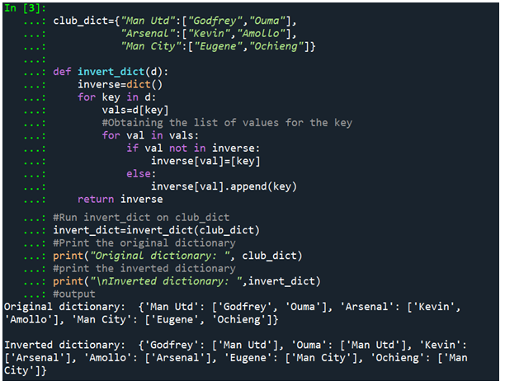
The code above shows the modified invert_dict function executed on club_dict to print both the original and inverted dictionaries. The original dictionary has football clubs as keys and lists of people supporting the clubs as values. On the other hand, the inverted dictionary has name of the people supporting the clubs as the as keys, while lists of football clubs becomes the values. The above observation corroborates with Raj’s (2022) assertion that reversing a particular Python dictionary results in changing the order of values in the key-value pair. Therefore, the current key becomes the value and the current value becomes the key in the new dictionary. The two outputs make it easier to observe football clubs and their respective funs and vice versa, making the dictionary suitable for managing and exploring shared interests among different people.

Reference
Downey, A. (2015). Think Python: How to think like a computer scientist. Green Tree Press.
Raj, A. (2022, March 3). Reverse a dictionary in Python. PythonForBeginners.com. https://www.pythonforbeginners.com/basics/reverse-a-dictionary-in-python

